Implementation of LOOCV for Weekly Dataset

QUESTION:8

we saw that the cross_validate() function can be used in order to compute the LOOCV test error estimate. Alternatively, one could compute those quantities using just sm.GLM() and the predict() method of the fitted model within a for loop. You will now take this approach in order to compute the LOOCV error for a simple logistic regression model on the Weekly data set. Recall that in the context of classification problems, the LOOCV error is given in

(a) Fit a logistic regression model that predicts Direction using Lag1
and Lag2.

Code:
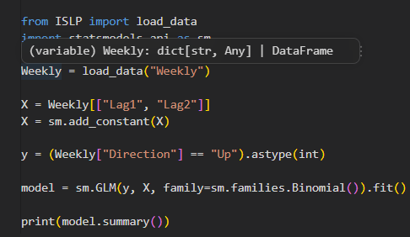

Output:
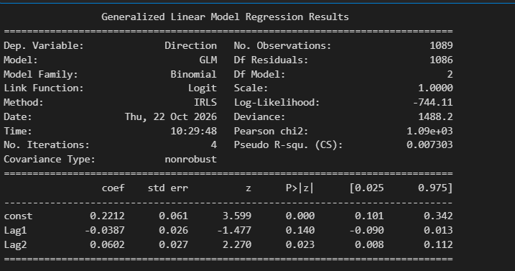

Interpretation:
The logistic regression model shows that Lag2 is a significant predictor of market direction (p-value = 0.023), while Lag1 is not statistically significant.

(b) Fit a logistic regression model that predicts Direction using Lag1 and Lag2 using all but the first observation.

Code:
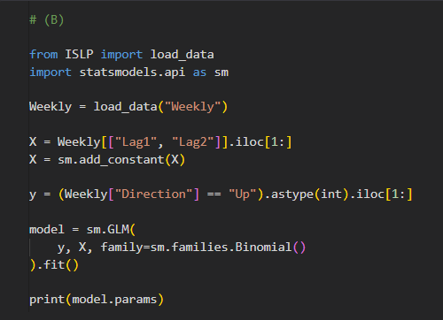

Output:
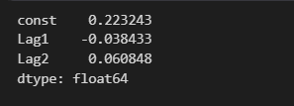

Interpretation:
The logistic regression model shows that Lag2 is a significant predictor of market direction (p-value = 0.022), while Lag1 is not statistically significant (p-value = 0.143).

(c) Use the model from (b) to predict the direction of the first observation. You can do this by predicting that the first observation will go up if P(Direction = "Up"|Lag1, Lag2) > 0.5. Was this
observation correctly classified?

Code:
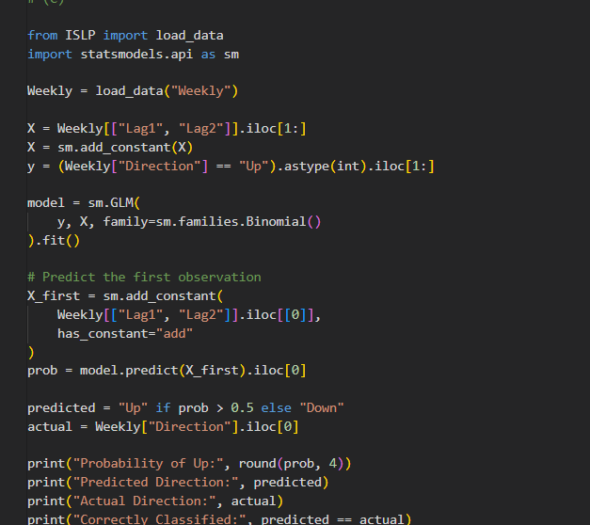

Output:
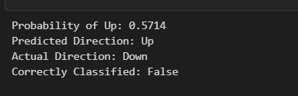

Interpretation:
The model predicted the first observation as “Up,” but the actual direction was “Down.” Therefore, the observation was incorrectly classified by the model.
(d) Write a for loop from i =1 to i = n, where n is the number of observations in the data set, that performs each of the following steps:

i. Fit a logistic regression model using all but the ith observation to predict Direction using Lag1 and Lag2.
Code:
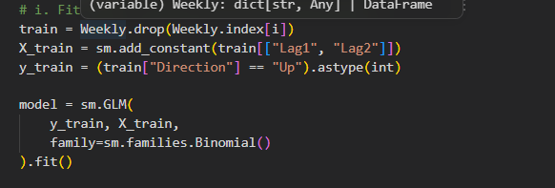
ii. Compute the posterior probability of the market moving up for the ith observation.
Code:
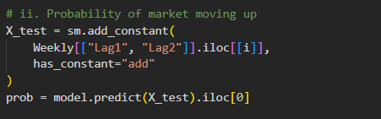
iii. Use the posterior probability for the ith observation in order to predict whether or not the market moves up.
Code:
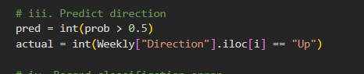
iv. Determine whether or not an error was made in predicting the direction for the ith observation. If an error was made, then indicate this as a 1, and otherwise indicate it as a 0.
Code:
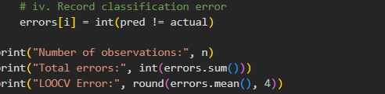
Output:
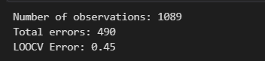
Interpretation:
The LOOCV error rate is approximately 44.995%, meaning the model incorrectly predicted the market direction in about 45% of the observations. Therefore, the model correctly classified approximately 55% of the observations.

(e) Take the average of the n numbers obtained in (d)iv in order to obtain the LOOCV estimate for the test error. Comment on the results.
Code:
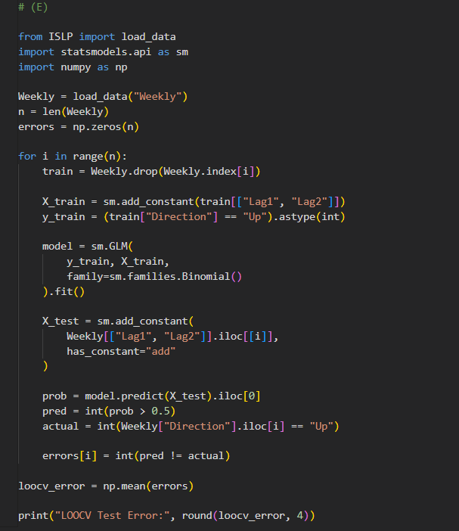
Output:
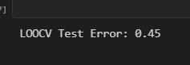
Interpretation:
The LOOCV test error is approximately 44.995%, indicating that the model misclassifies about 45% of the observations. This suggests that the model has moderate predictive accuracy, correctly predicting the market direction in approximately 55% of cases.

